Final Project Report

*Vegan in HK Website*

Link: <https://glynn0729.github.io/Final_Project/Vegan_in_HK/index.html>

Glynn Lu, 1155131858

### Introduction

With the aim of making vegans’ life easier and better, Vegan in HK is a website designed for Hong Kong vegan residents as well as visitors to find nice and suitable food for consuming. In this report, the process of building this data-driven website will be elaborated.

### Strategy

### Site objectives

The idea of designing a food recommendation website especially for vegans is motivated by my own experience. As a vegan who newly come to Hong Kong, I found it is extremely hard to meet my special diet when eating outside, since most of the restaurants provides few vegetables and the price is considerably high. Moreover, finding the suitable place where sells fresh vegetables and fruits is difficult as well, for most fruits and vegetables in supermarkets are imported and quite expensive. My interview with several vegetarian friends studying in Hong Kong indicates the similar problem as I encountered.

Thus, there comes the problem I intend to fix through designing a data-driven website: How to help vegans in Hong Kong to sustain their special diet in an economical way, and finally make their vegan lifestyle more convenient and interesting? And the goal of this website contains two parts: 1. Help vegans save time on information searching when they want to consume vegan food in Hong Kong. 2. Make HK vegans’ diet more diverse, interesting and at the same time save money.

### User needs

The targeting users of this website mainly includes 2 groups: 1. Local vegans who live in Hong Kong. 2. Vegans who newly come and would stay in Hong Kong for a while. In order to find out the needs of my user segment, I interviewed several vegans in Hong Kong and other countries by asking the following two questions (See Figure 1)

|  |
| --- |
| *Q1: How do you find vegan food? What kind of website will be used during searching?* |
| *Q2: What kind of information or services you expect to find in a website serves for vegans?* |

*Figure 1 User needs interview-questions*

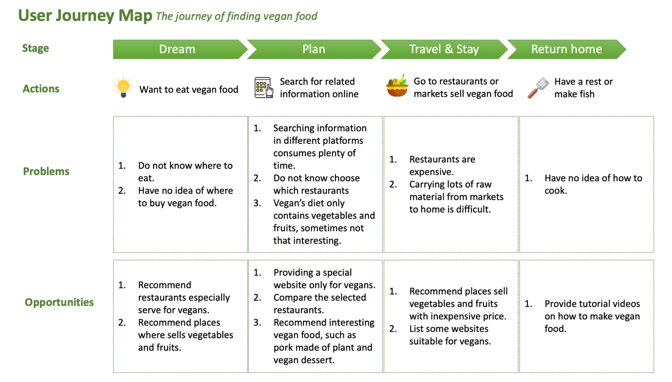Based on the feedback of interview, I develop a user journey map to see how a vegan find the suitable food, examining user needs and explore the opportunities I could seize for website development in a more micro perspective. (See Figure 2)

*Figure 2 User Journey map- the journey of finding vegan food*

According to the journey map, I reclass the information user need into 3 categories: 1. Vegan restaurants 2. Places where could buy vegetables and fruits 3. Tutorial videos on how to make vegan dish.

### Scope

### Functional specifications

There are mainly 3 functional specifications of my website when compared with the existing ones in the market.

Firstly, this website is especially for vegan. Actually, there are many different kinds of vegetarians, while vegans are the ones who keep the most rigid eating habit, never consuming any animal product such as milk, butter or cheese. Although there are several existing vegetarian-related websites in Hong Kong, most of them serves for the larger vegetarian group and mainly focus on promoting the benefits of keeping a vegetarian diet. None of these platforms are especially designed for vegan and authentically help them to find the desirable food.

Secondly, it is unwise to compete with *OpenRice*, a Hong Kong food recommendation service giant, directly in the aspect of information volume. Thus, my website lists selected vegan restaurants and compare them through data visualization to help users choose restaurant more quickly. Moreover, unique sections are designed to classify different choices, creating interesting scenes to diversify eating experience.

Last but not least, in addition to restaurants recommendation, my website does offer information to help vegans make dish at home through telling users where to buy fruits and vegetables both offline and online. And tutorial videos are listed to empower vegans make delicious food at home.

### Content requirements

The following contents are finally considered to be listed on my website.

1. 25 vegan restaurants with information includes picture, location, average expense, rate of good comment, short description, cuisine category.
2. 97 Hong Kong street markets with information includes, location, contact information, opening time, number of fruit shop and vegetable short inside.
3. 6 websites which sells vegan food with link, short description, delivery information.
4. 9 tutorial video which teaches vegans how to make dish at home.

### Structure

After defining the problem and user needs, an information architecture is developed to make all the content logical and well connected. Please see the site map of Vegan in HK as Figure 3. Three categories marked with green stars are the main functional sections, storing the information which vegans needs to find suitable food in Hong Kong. Moreover, contact us section is design for feedback collecting and footer includes copyright, contact information, navigation as well as an overall description of this website.

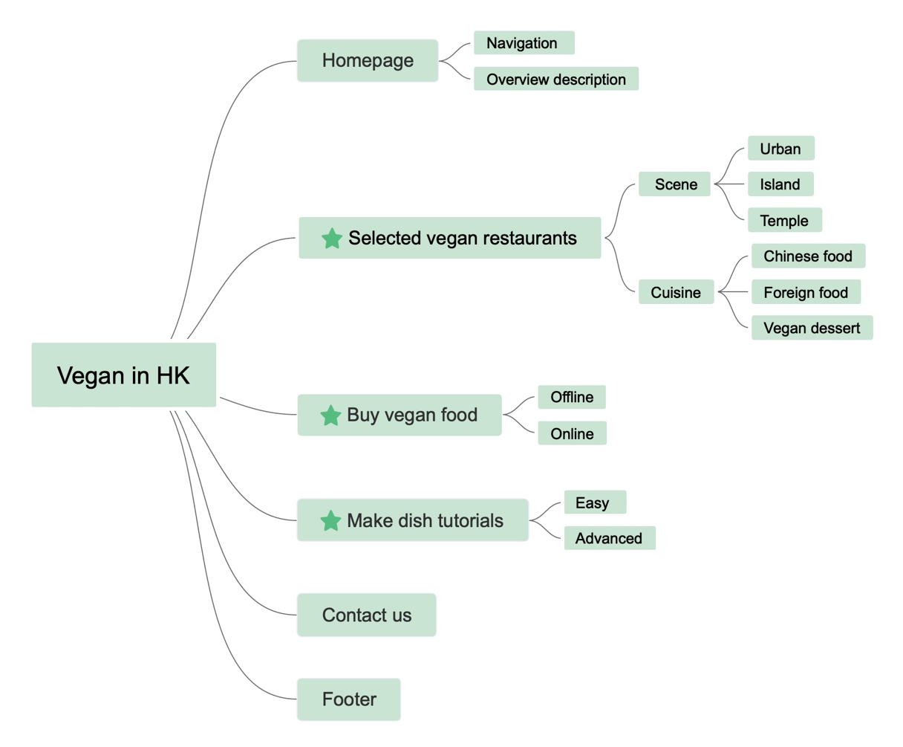

*Figure 3 Site map- Vegan in HK*

### Skeleton

During the prototyping stage, a low-fidelity wireframe of my website is developed according to the information hierarchy, depicting the interface and navigation design in a more figurative way. (See Figure 4-9) In order to validate if users could go through my web pages smoothly according to my embedded navigation, I interviewed 5 people to gain feedback for further improvement. Three suggestions from my respondents are highly intelligent and valuable: 1. *Arron* said it could be much better if there’s a “start” button on the center of the landing page since this would make users spend less time on scrolling the screen. 2. *Qian* suggested the link embedded in the pop-up window of map function should be connected to google map. By doing so, when user click the link, google map app could be called out automatically and guide users travel to the restaurants. 3. *Lei* thought the color of the filtering button should be changed when it is selected.

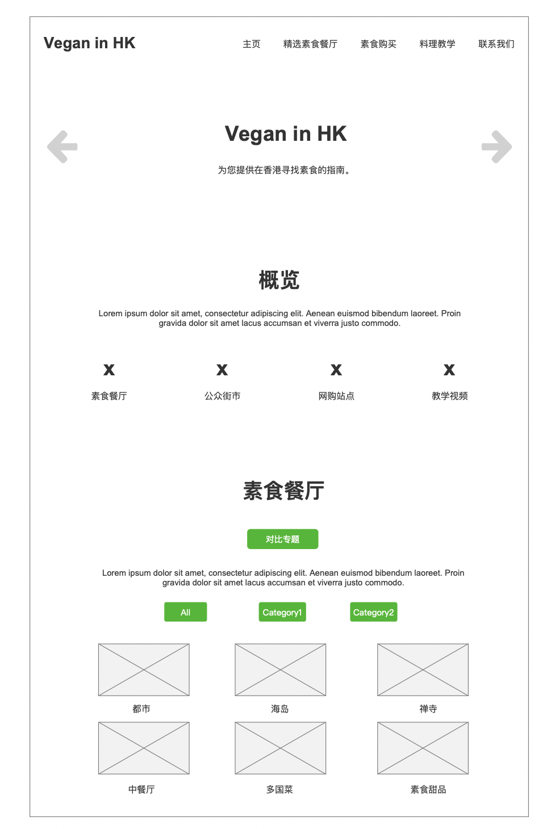

*Figure 4 Wireframe- Homepage part 1*

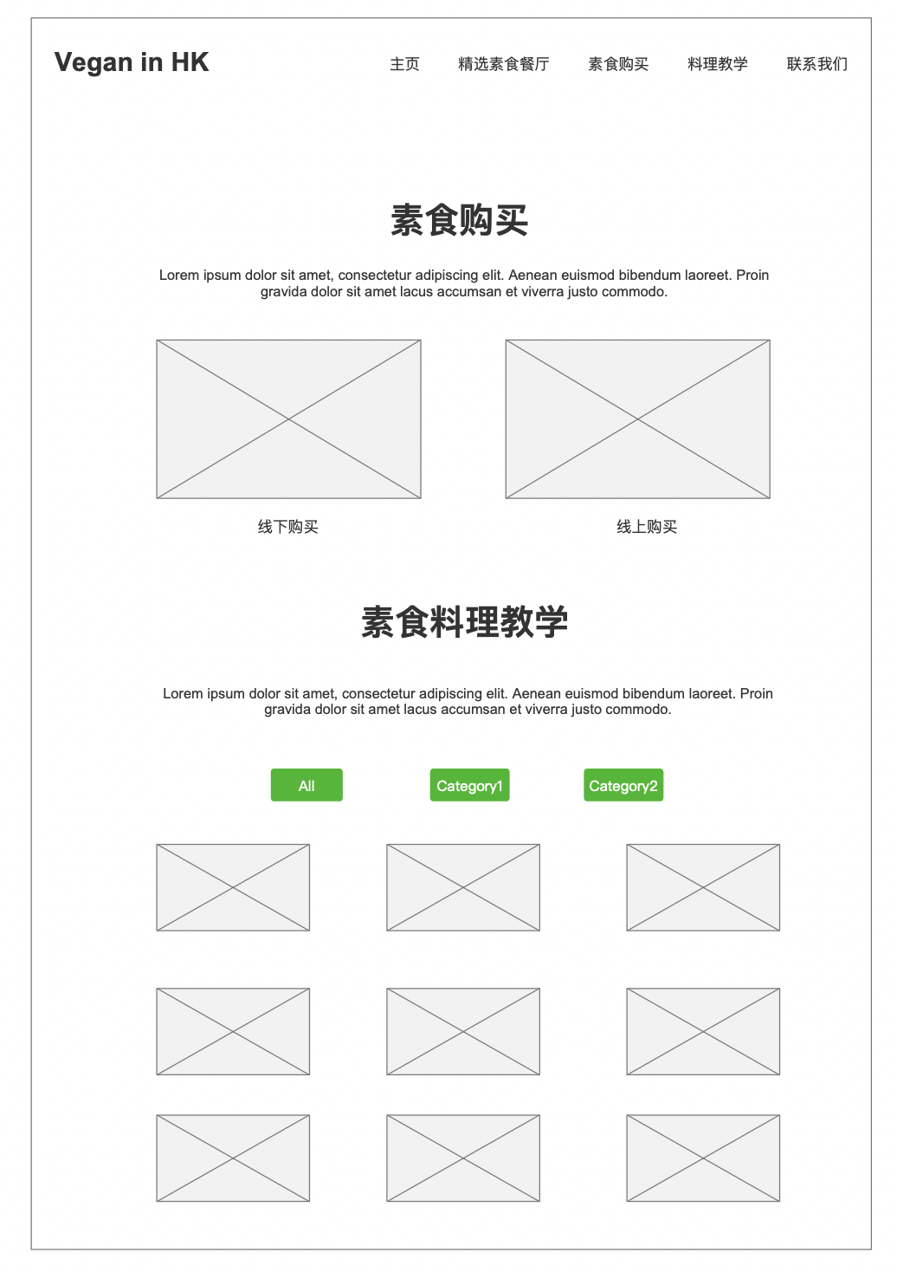

*Figure 5 Wireframe- Homepage part 2*

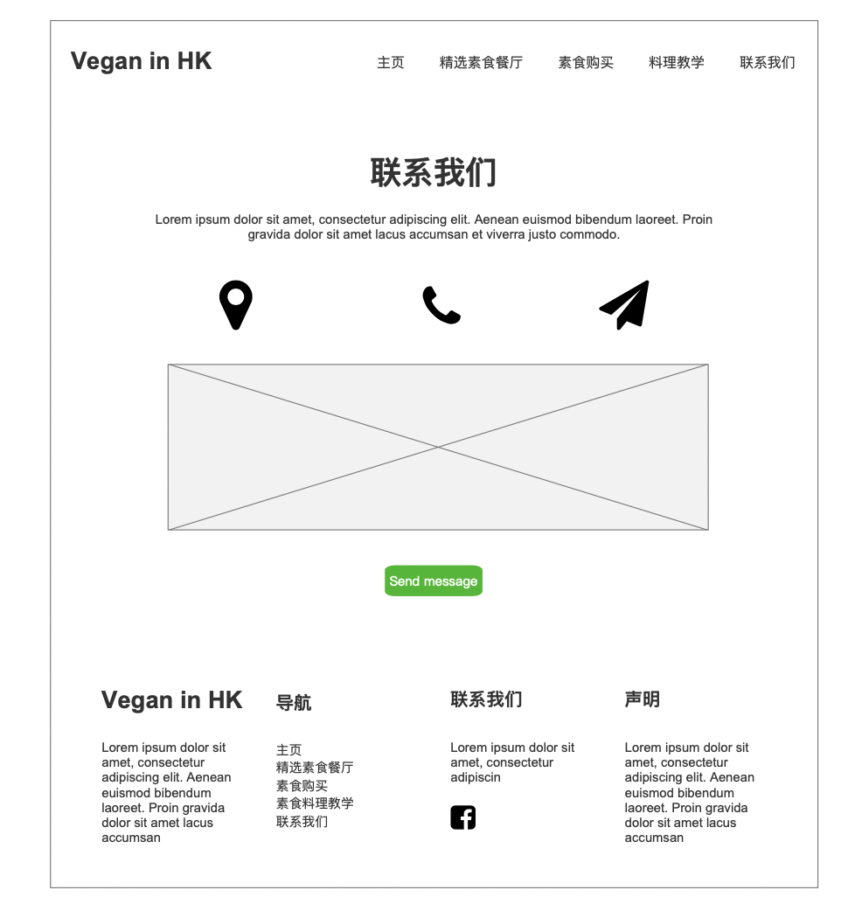

*Figure 6 Wireframe- Homepage part 3*

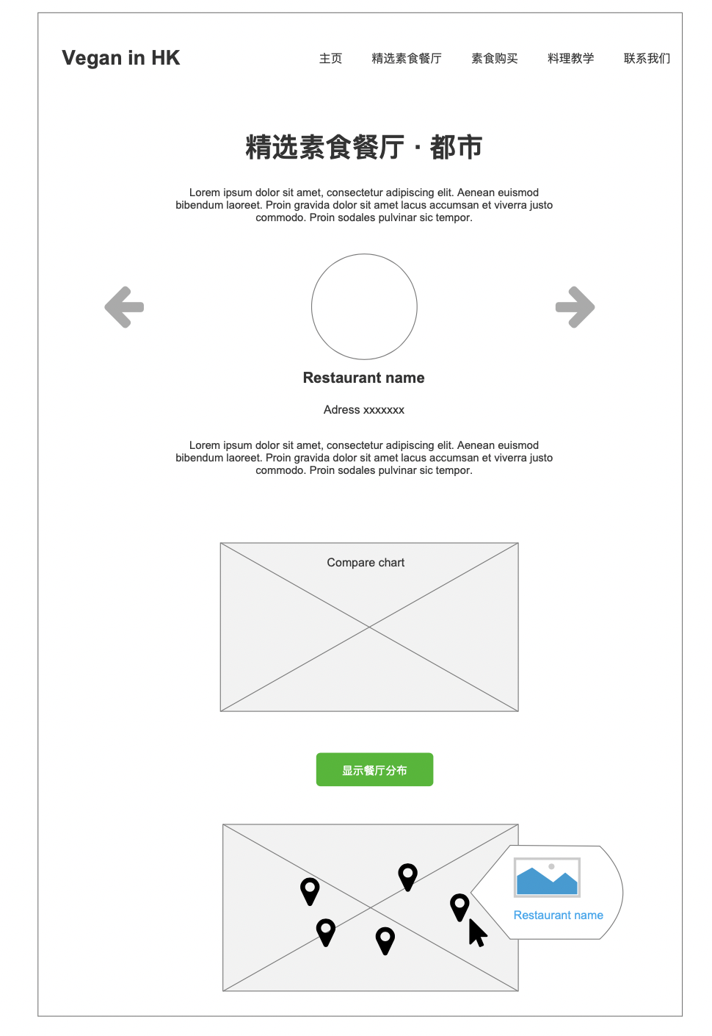*Figure 7 Wireframe- Selected vegan restaurants page*

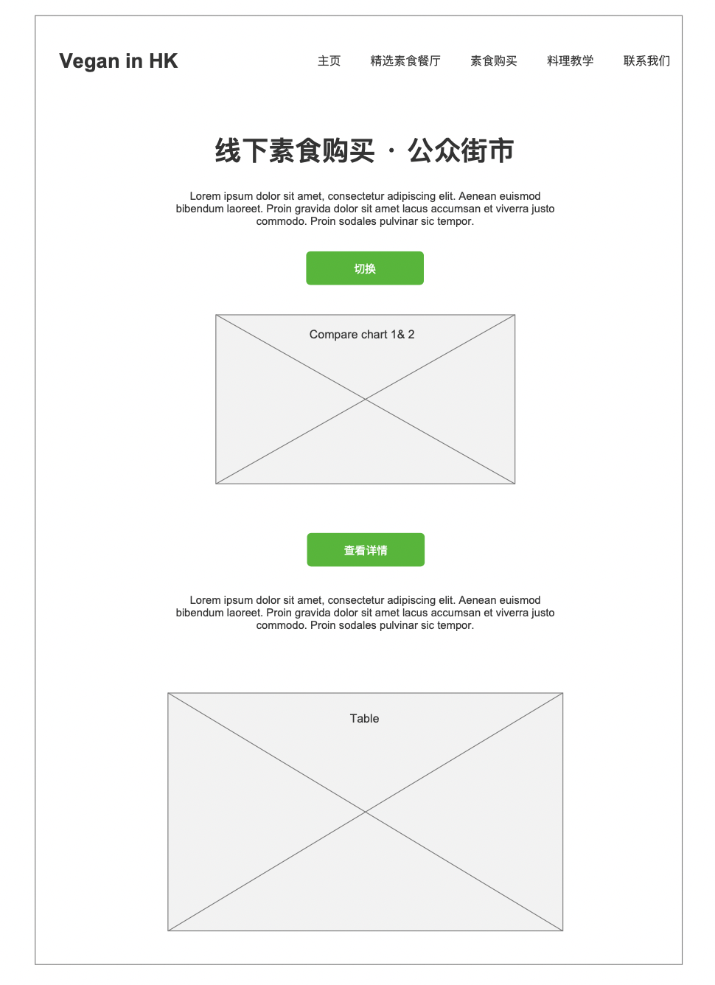*Figure 8 Wireframe- Buy vegan food page offline section*

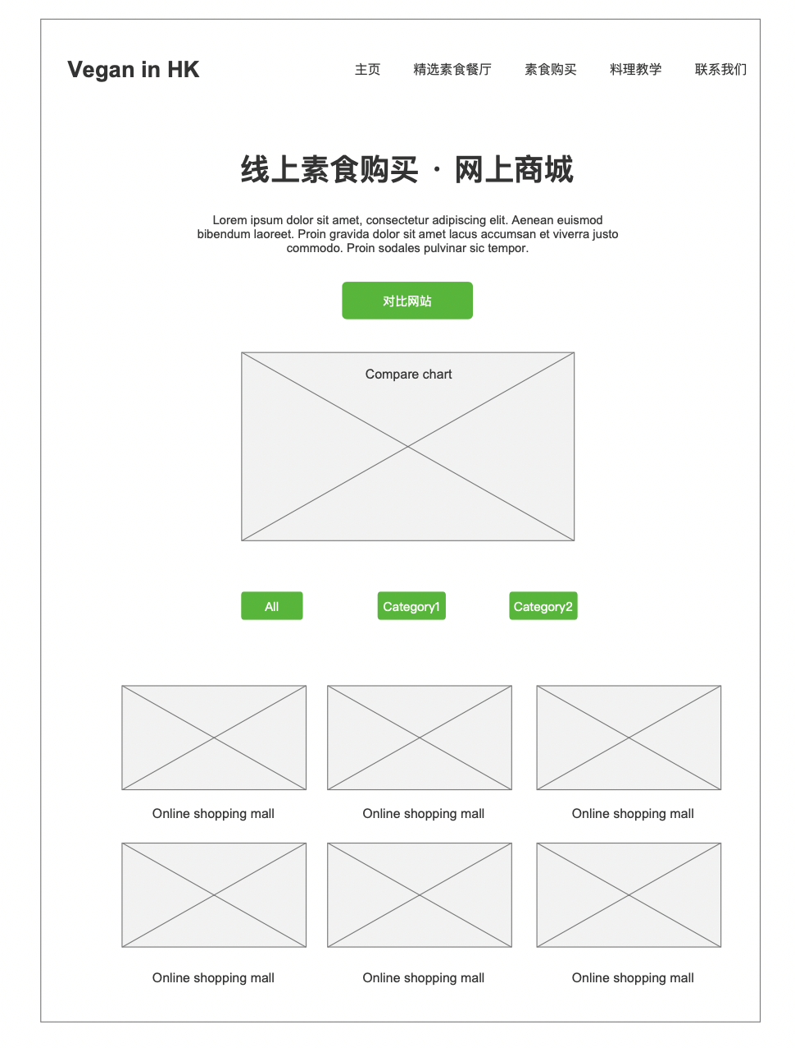

*Figure 9 Wireframe- Buy vegan food page online section*

### Surface

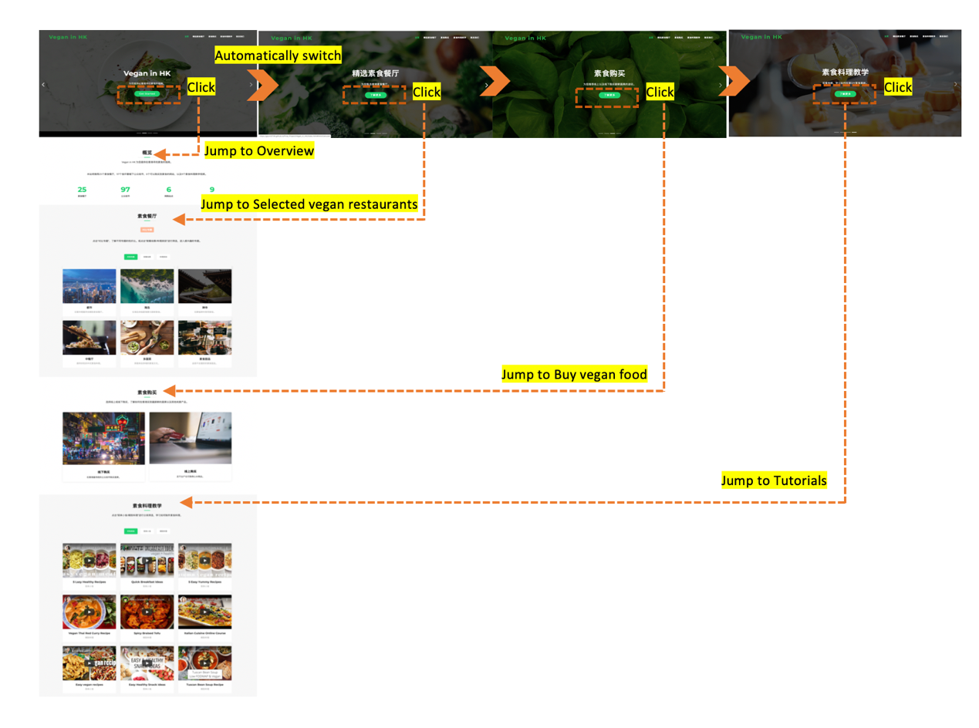Based on the wireframe and insights gained from usability test, I developed a multi-page website to present more information. In general, this website contains two hierarchies: 1. Homepage mainly provides navigation 2. Detailed page focuses more on functional visual design.

*Figure 10 Homepage navigation design logic*

When users landing to my homepage, the first thing they see would be a set of automatically playing pages (See Figure 10). Each page consists a short description and a clickable button which leads users jump to the main section quickly. This idea is partly inspired by the advice gained from usability test. It helps users save energy spent on scrolling pages and get more easily to arrive their interested sections.

In “精选素食餐厅” section, I classified 25 selected vegan restaurants and cafes into 6 themes including: Urban, Island, Temple(grouped according to the environment), Chinese cuisine, Foreign cuisine and vegan dessert (grouped according to the cuisine), to deliver the message that vegan diet could be diverse and fancy as well. Moreover, to meet the goal of making vegan’s life more economical, I provide “price-rate of good comment” chart to visualize the data, thus assisting the users make decision quickly. The charts are employed not only in comparing different themes but also the specific restaurants. (See Figure 11) At the same time, the map shows the location of each restaurants. When user click in the pop-up window in the map, they would jump to google map directly, which saves extra steps for users if they want to search the route from their home to the destination. (See Figure 12)

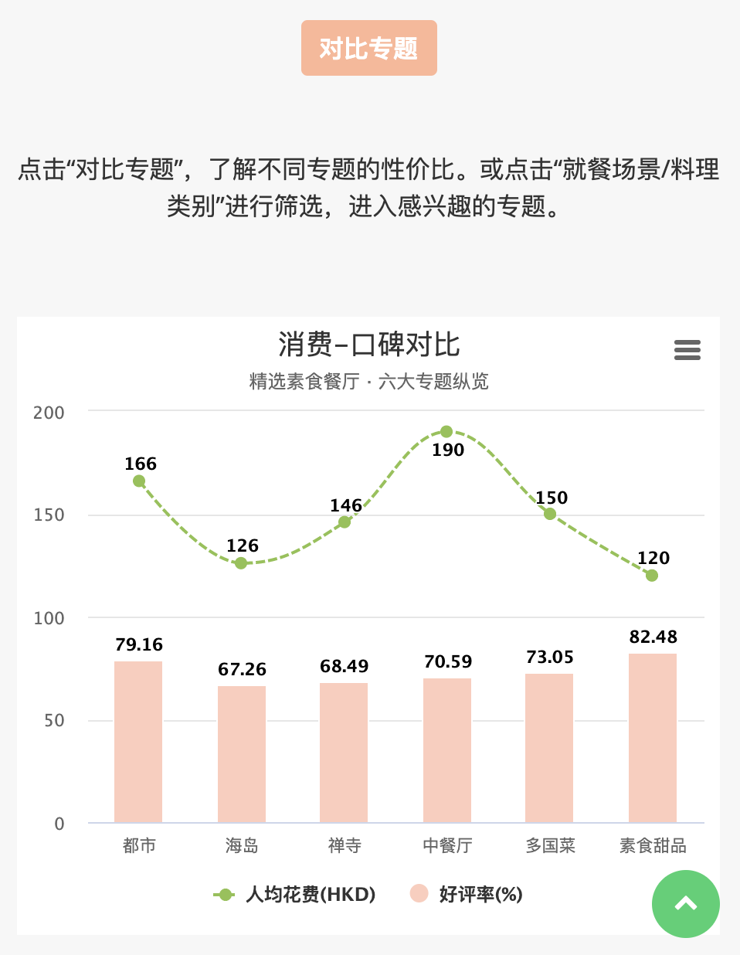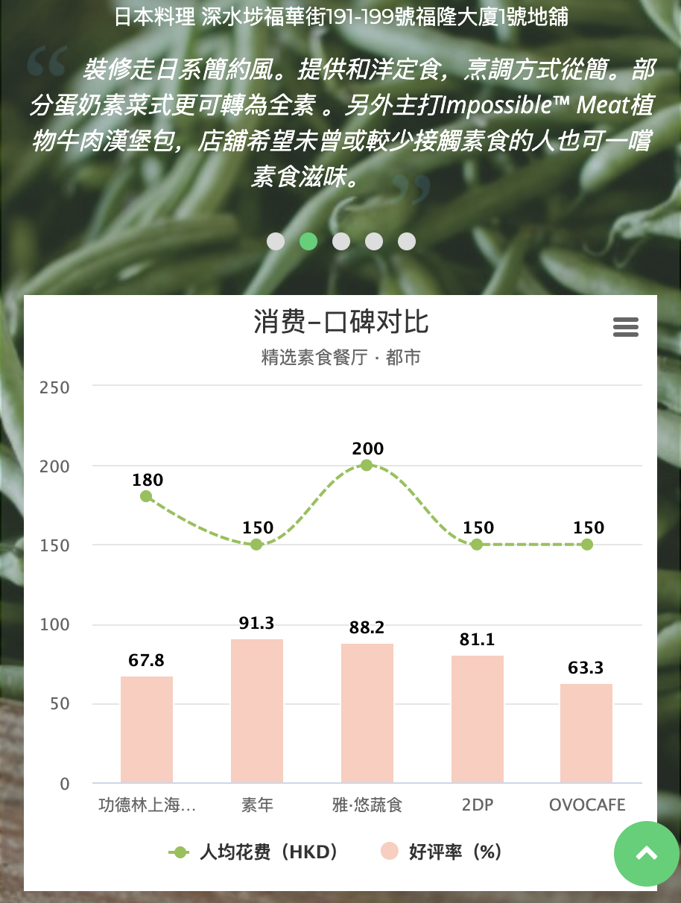

*Figure 11 Detailed page- Data visualization “price-rate of good comment” chart*

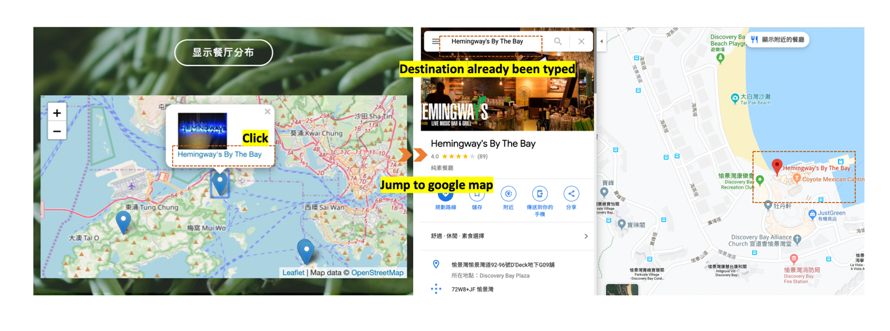

*Figure 12 Detailed page- Map function*

In “素食购买” section, I employed bubble chart to compare 97 street markets under HK Food and environmental hygiene department, using number of fruit shops and vegetable shops in each market as dimensions. Also, I defined the top 10 markets which are suitable for vegans based on the ranking and provide all the detailed information in *Airtable* classified by districts. (See Figure 13)

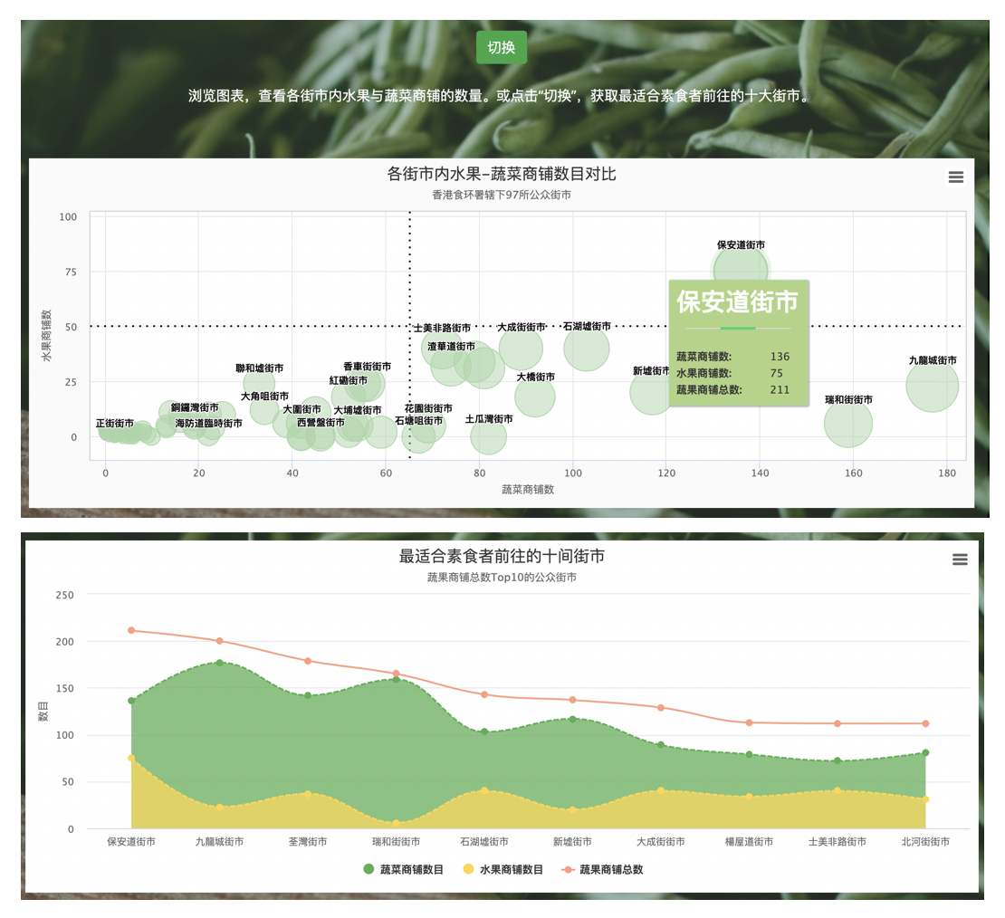

*Figure 13 Detailed page- Data visualization bubble chart and combined chart*

### Evaluation

### Usability Test

To validate whether users could understand the interface design in visual level, 5 participants were invited to join in my usability tests. All the respondents are required to think aloud when going through the pages, thus I could observe how they interact with my webpage in a more precise way.

Three tasks are designed as following:

1. *Go through the website freely for 3 minutes and think about the most valuable information you get and the most confused content you encounter.*
2. *Select a vegan restaurant you are interested and figure out how to get there.*
3. *If you are living in Sha Tin, New Territories, find out the nearby street market according to the information of this website.*

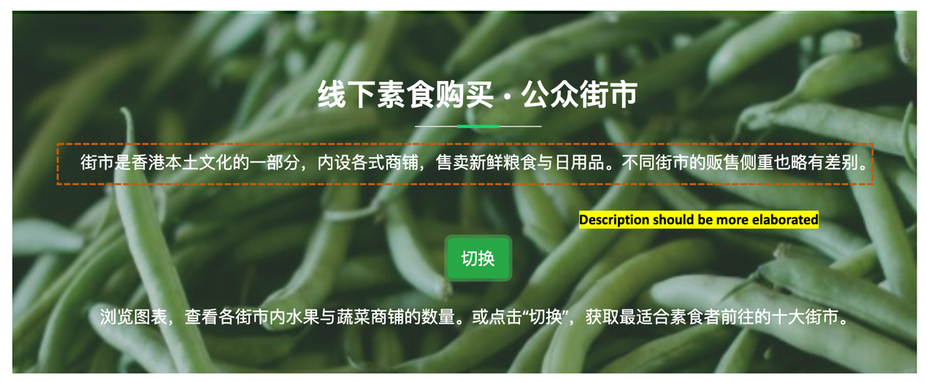In task 1, most participants said they appreciated the simplified aesthetic design of the webpage and considered the navigation is user-friendly. All of them got the main function and the objective of this website. However, one mainland China user suggested the description of “街市”(Street market) should be elaborated since this localized name may confuse the non-local users to some extent. (See Figure 14)

*Figure 14 Usability Test feedback 1*

In task 2, 4 of 5 users utilized the map function well, directly jumped to google map without texting the restaurants location again, while all the users said they expected to see the detailed information of the restaurants such as the recommended dish, surroundings and interior decoration. In task 3, 2 users chose online shopping and 3 users successfully found the specific street market within 45s, which indicates the function design and navigation are reasonable and powerful.

In addition to the suggestion directly mentioned by the participants, there are two problems I observed from their exploring process. Firstly, 3 users tried to click the number in overview section while it was not set any link. (See as Figure 15) This indicates that users need this kind of navigation which sends them directly to the interested content. Secondly, the click rate of several certain buttons was not as high as the original expectation, which inspired me to launch a A/B test to find a way attracts more clicks.

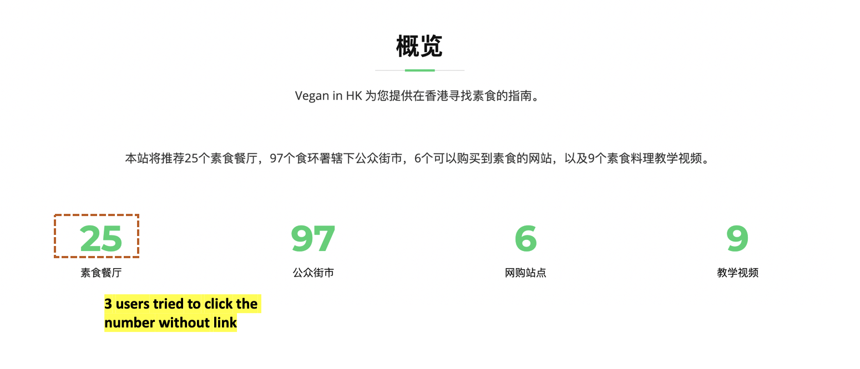

*Figure 16 Usability Test feedback 2*

### A/B Test

To maintain the aesthetic design simplified and unified, all the buttons were set as green or white initially. However, during the usability test, I observed that most participants ignored some buttons which are designed for showing the hidden content. Assuming that a button with distinctive color could attract more interactions, I turned the color of “compare” button into pink to differentiate it from others. (See as Figure 17) To figure out if this variation could contribute to a better performance, a A/B test empowered by *Google Optimize* was launched from Dec.1st to Dec.8th for quantitative testing.

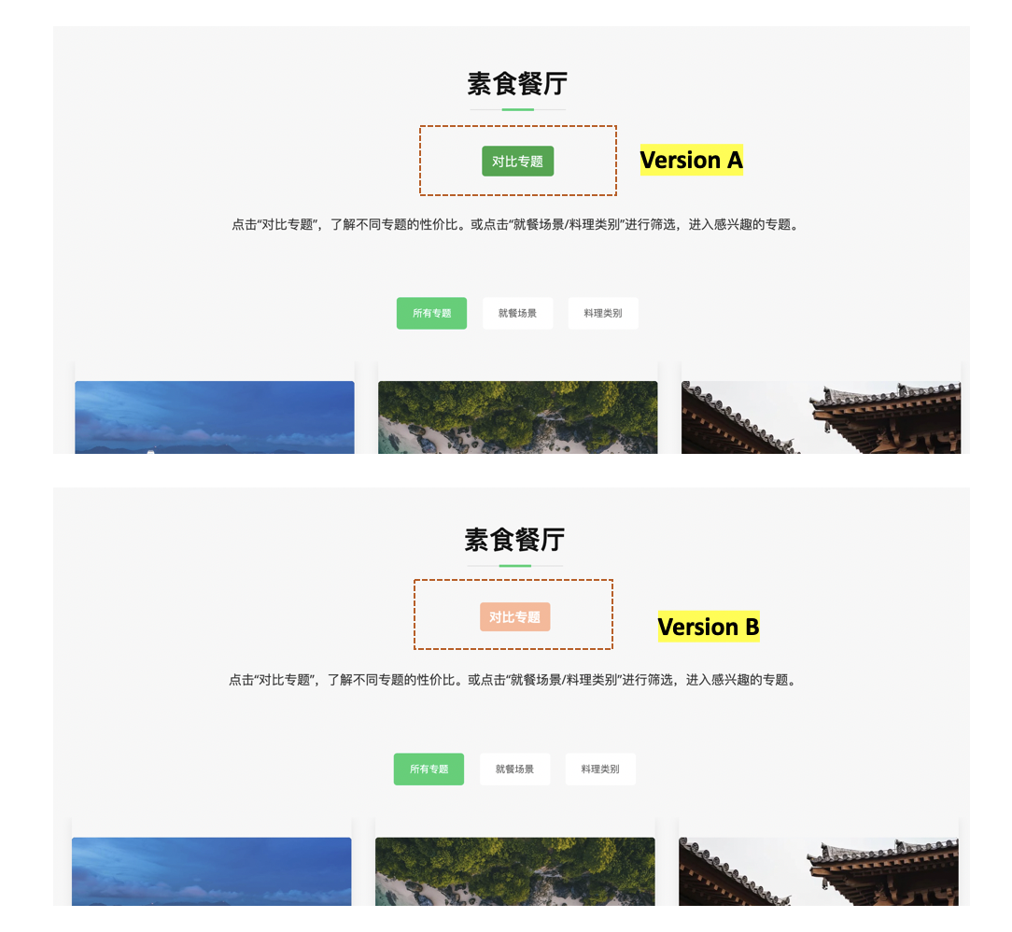

Figure 17 A/B Test – Screenshot of version A & B

After running the test for eight days, version B performed better than version A, and it not only gained more clicks, but also contributed to a longer average working duration (4 min 48s Versus 1 min 58s) and more page views (4.67 Versus 3.71). This partly validate the original assumption that a button with eye-catching color is able to call more actions, thus reaching a higher conversion rate through generating more interaction. (See Figure 18) Inspired by the result of this experiment, all the call-to-action buttons were turned to a more unique color for improvement.

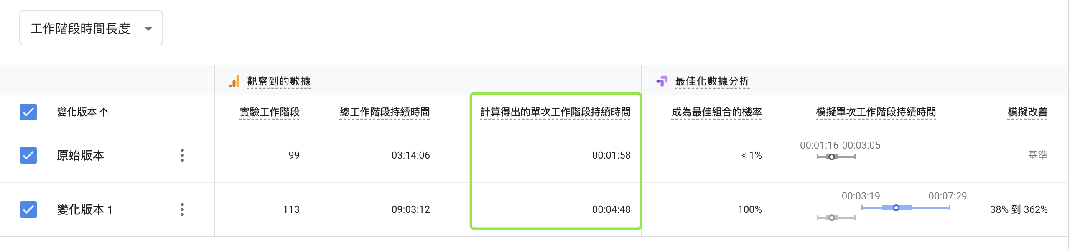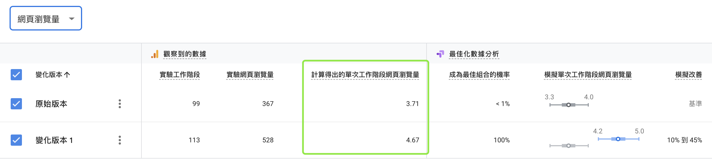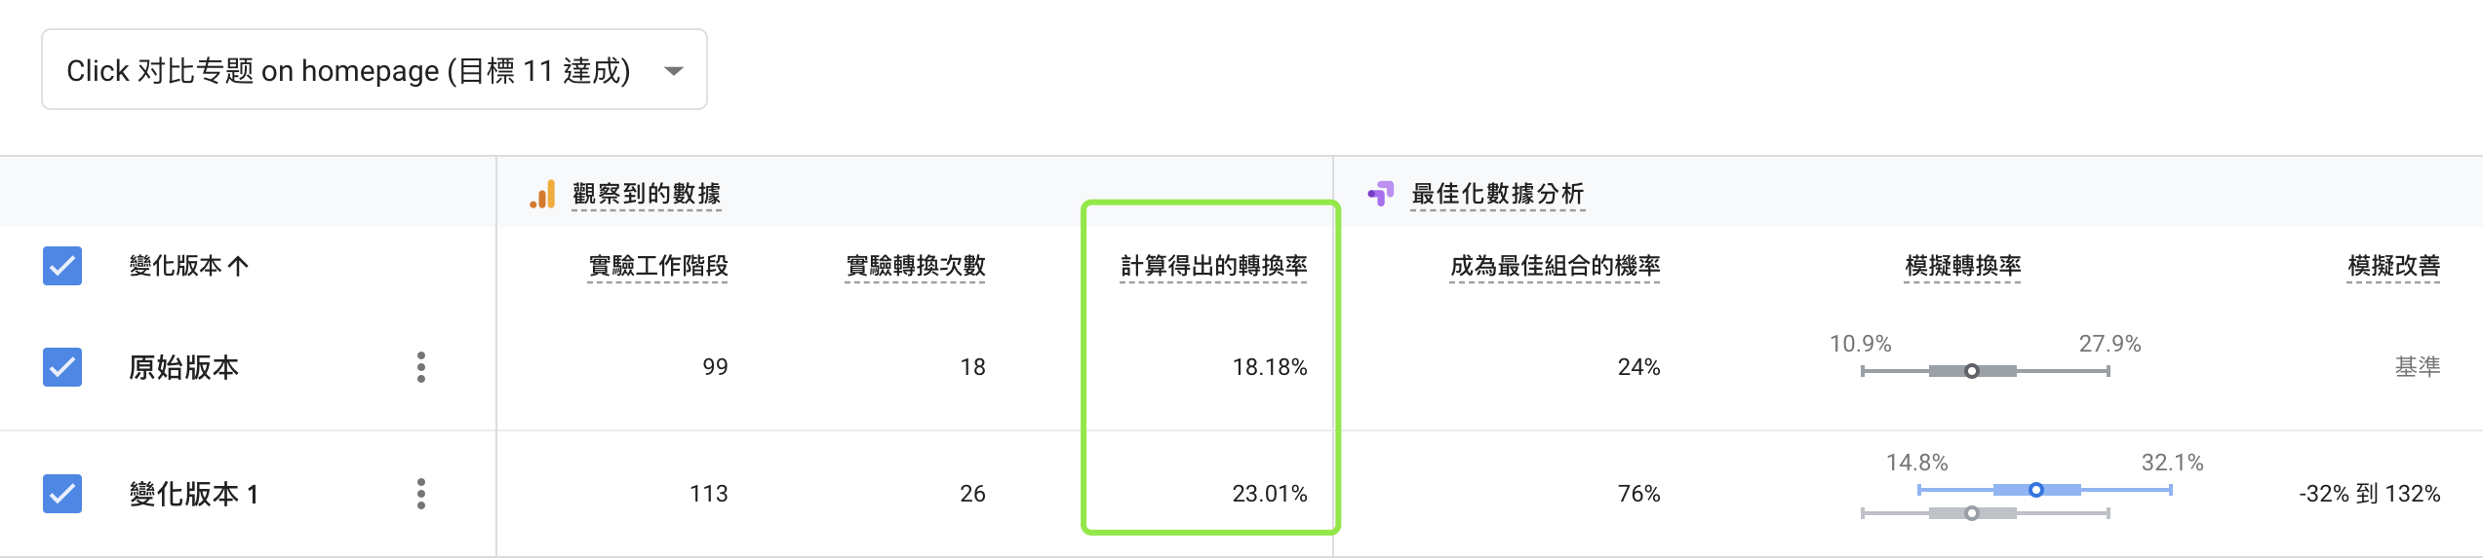

*Figure 18 A/B Test – Google Optimize analysis*

### Web analysis

In order to measure the performance of my website and find some insights for future development, I utilized Google Analysis along with Google Tag Manager to track user behavior. After running data from Dec.1st to Dec.8th, a dashboard with 9 metrics including visitors, average working duration, view pages, bounce rate, visitor category, device, media source, countries and interaction event, was customized for evaluation (See Figure. 19).

In general, the overall performance of this website is satisfied for the average page view reaches 6.54 and the working duration per person exceeds 5 minutes. Although the bounce rate is considerably high, this is due to 65.91% users come from China, whose web page loading speed is restricted by the great fire wall. The returning visitor occupies 16.9% during the past 8 days, which proves my website is able to appeal users to come back. Nearly 70% users using mobile, indicating web design in the future 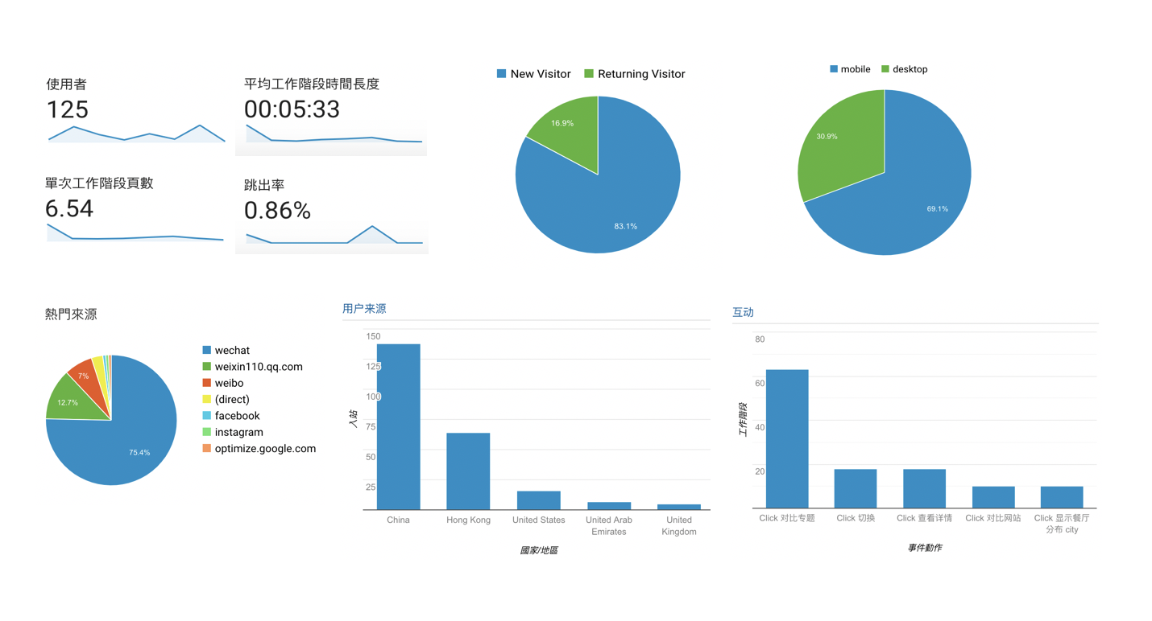should focus more on how to optimize information display on smaller screen.

*Figure 19 Google Analytics- Customized Dashboard*

UTM coding was utilized to track the traffic source and analyzing source traffic is very meaningful when a comprehensive media planning strategy is utilized. However, during the promotion, no paid advertising was employed, the majority of users are my acquaintance, reached through direct message and posts on different social platforms. Since most of my friends use Wechat and Weibo, these two meida accordingly gain the most traffic.

With the support of Google Tag Manager, clicks on each button was tracked. According to the dashboard, the button “对比专题” on the homepage gained the most clicks. Also, the “切换” and “查看详情” button on Buy Vegan food offline page were clicked frequently as well, which gives insight that user are rather interested in this section. The page view ranking also validates user did care about how to buy vegan food both online and offline, the number of view even exceed all the sub-pages in Selected vegan restaurants category. (See as Figure 20)

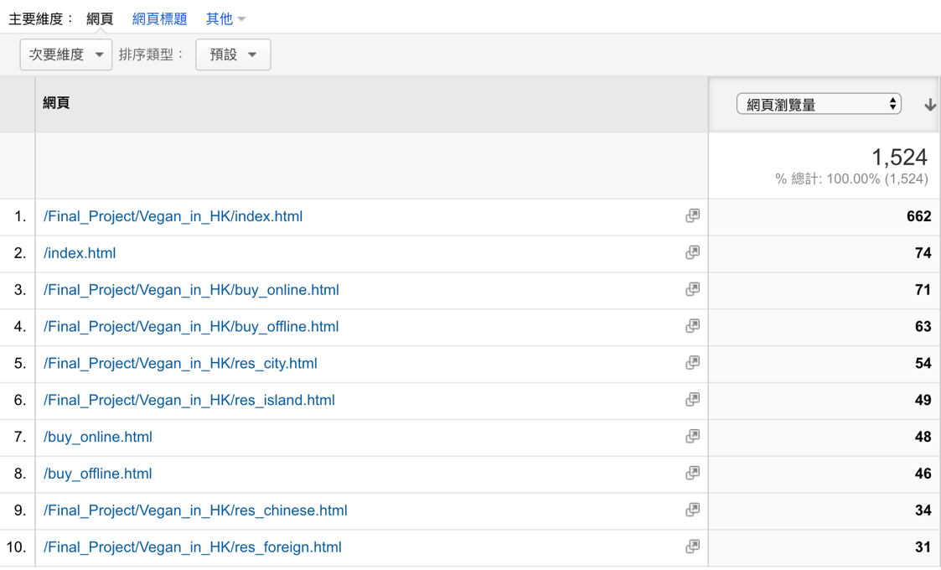

*Figure 20 Google Analytics- The top5 popular pages*

#### Conclusion

### Limitations

In general, there are mainly three limitations which to some extent affect the performance of my website. Firstly, during the evaluation stage, because of the current socio-political situation in Hong Kong, it gets more difficult to promote this HK-related website on mainland China social media platforms. Accordingly, data for further improvement were mostly generated by my own social circle, and few of this group are my targeting users. Secondly, since I know little about Cantonese and Hong Kong culture, this restricts me from interviewing more local vegans and detecting the needs of this segment precisely thus making the website more localized. Finally, considering I am the beginner of HTML5/CSS/JavaScript, the ability of coding limits me from completely visualizing my idea, thus several functional designs have to be abandoned.

### Improvements for the future

After going through the whole process of building this website, two meaningful insights came to my mind during the reflection journey. On the one hand, a section focus on balanced nourishment is necessary since vegan’s single diet may affect their health. This makes the whole website solve the defined problem better for it provides another dimension to attract users. On the other hand, a single page website may extend the user working duration since Google Analytics shows when user traveled to another page within the website, part of them bounced out before actually landed to. However, this requires higher programming capabilities to present the content interactively and flexibly.